Predictive modeling of Material Take-off Overrun Risks in Brownfield EPC Projects
A Dual-Task Machine Learning Approach to Quantifying MTO Growth for Proactive Cost Control
Engr. Julie Anne-Mae Vanta Villanueva
E-mail: jamvanta06@gmail.com
October 8, 2026
Capstone Project
In partial fulfillment of the requirements for the
Postgraduate Diploma in Artificial Intelligence and Machine Learning at the
Asian Institute of Management (AIM)

Executive Summary
Brownfield revamps in the Engineering, Procurement, and Construction (EPC) oil and gas sector often suffer severe capital expenditure overruns due to unexpected Material Take-Off (MTO) volume growth. Conventional estimation practices apply static, across-the-board contingency markups (typically 10% to 15%), treating benign utility lines identically to high-pressure, severe-temperature, or exotic metallurgy circuits. This blanket heuristic fails to capture complex spatial and operational constraints, resulting in unplanned procurement re-orders, high-premium freight expediting, and construction schedule delays.
This project established an end-to-end, dual-task machine learning framework that converts early Front-End Engineering Design (FEED) parameters into predictive risk intelligence. Because historical engineering and procurement registers are bound by strict corporate non-disclosure agreements, a domain-synthesized dataset of 8500 brownfield process piping subsystems across 10 distinct capital projects was generated to emulate real-world operational distributions without privacy exposure. Domain-engineered interaction features, specifically a Process Severity Index (P x T) and a Brownfield Complexity Penalty (physical tie-in density penalized by unverified 3D laser scan coverage), were introduced to capture compounding site risks.
Model validation was conducted under a 5-fold Group K-Fold strategy grouped strictly by historical Project ID, preventing data leakage and directly simulating deployment onto unseen facilities. In the binary classification task (flagging lines with overruns > 15%), LightGBM achieved champion performance with a Precision-Recall Area Under the Curve (PR-AUC) of 0.9741, outperforming Logistic Regression (0.9719), XGBoost (0.9703), and Random Forest (0.9668). In the continuous regression task (quantifying exact percentage growth), LightGBM established the lowest error profile with a Root Mean Squared Error (RMSE) of 3.5090% surpassing XGBoost (3.7176%), Random Forest (3.7756%), and Ridge Regression (3.7979%).
Model explainability and algorithmic fairness audits were integrated to ensure stakeholder transparency. Prediction residual audits across estimator teams and major supply chain vendors verified unbiased, zero-centered error distributions. Global and local Shapley Additive exPlanations (SHAP) demonstrated that low FEED maturity, high tie-in density, and absent laser scan coverage are the primary variance drivers. For business stakeholders, replacing flat markups with this dual-task framework enables risk-adjusted, line-item contingency allocations, preventing procurement re-orders while sharpening competitive bid margins on brownfield EPC tenders.

Contents

Executive Summary 2
Nomenclature: Acronyms and Definition of Terms 4
Part A: EPC & Process Engineering Terms and Acronyms 4
Part B: Machine Learning & Statistical Terms and Acronyms 5
1. Project Background 7
2. Problem Statement 7
3. Primary Objectives 7
4. Task Definition 8
5. Target Metrics and KPIs 8
A. Technical Success Metrics 8
B. Business Key Performance Indicators (KPIs) 8
6. Data Collection 9
7. Feature Summaries and Variable Types 9
8. Treatment of Missing Values and Outliers 10
9. Data Dictionary 11
10. Data Preprocessing & Feature Engineering 13
11. Exploratory Data Analysis & Dimensionality 13
12. Feature Selection & Model Explainability 15
13. Cross-Validation Strategy (Simulating Real-World Deployment) 16
14. Classification Task: Predicting High-Risk Overruns (> 15%) 16
15. Regression Task: Quantifying Exact MTO Growth 18
16. Bias & Fairness Analysis 20
A. Ethical AI & Fairness Auditing 20
B. Local Explainability (SHAP Waterfall) 21
C. Limitations and Mitigations 22
APPENDIX: List of Attachments and Project Artifacts 23

Nomenclature: Acronyms and Definition of Terms

Part A: EPC & Process Engineering Terms and Acronyms
Term / Acronym | Full Expansion | Definition
EPC | Engineering, Procurement, and Construction | A project delivery contracting arrangement where a contractor designs the facility, purchases all required equipment and materials, and executes construction.
Brownfield Project | -- | An industrial upgrade or modification project executed inside an existing, older, and often actively operating facility, characterized by tight spatial constraints and legacy infrastructure.
Greenfield Project | -- | A new-build project constructed from scratch on an empty, unobstructed plot of land.
FEED | Front-End Engineering Design | The early preliminary engineering phase where process blueprints and baseline material budgets are established before construction bidding.
MTO | Material Take-Off | The comprehensive master "shopping list" of all physical bulk materials (e.g., meters of piping, fittings, valves, and structural steel) extracted from engineering drawings for budgeting and purchasing.
P&ID | Piping and Instrumentation Diagram | Detailed schematic blueprints illustrating the process flow, piping lines, equipment, and control instrumentation of a plant.
Tie-in Density | -- | The integer count of physical connection points where newly designed piping must be welded or flanged into existing legacy plant headers. High tie-in density increases field routing complexity.
3D Laser Scanning | -- | Spatial surveying technology used to capture verified 3D digital geometry of an existing plant to prevent physical clashes during construction.
barg | Bar Gauge | A unit of pressure measured relative to ambient atmospheric pressure (1 barg is approximately 14.5 psi above atmospheric pressure).
Metallurgy (CS, SS, Duplex, Inconel) | Carbon Steel (CS), Stainless Steel (SS), Duplex, Inconel | The alloy specification of a pipe. Ranges from standard commodities (CS, SS) to exotic, corrosion-resistant superalloys (Duplex, Inconel) required for extreme temperatures, high pressures, or toxic fluids.
MOQ | Minimum Order Quantity | The smallest batch or packaging size a supply vendor is willing to sell, which can artificially inflate final purchased quantities on small piping lines.
As-Built Quantity | -- | The final, actual quantity of material purchased and physically installed in the field at project closeout.

Part B: Machine Learning & Statistical Terms and Acronyms
Term / Acronym | Full Expansion | Definition
EDA | Exploratory Data Analysis | The initial analytical phase using statistical summaries and visualizations to inspect data distributions, spot anomalies, and verify relationships before training models.
PCA | Principal Component Analysis | A dimensionality reduction technique that compresses correlated variables into a smaller set of uncorrelated components while retaining 95% of the original information variance.
t-SNE | t-Distributed Stochastic Neighbor Embedding | An unsupervised visualization algorithm that maps high-dimensional engineering data onto a 2D scatter plot to reveal natural clustering between high-risk and low-risk subsystems.
Group K-Fold (k=5) | -- | A cross-validation strategy that groups data by “Project_ID” so the model trains on historical projects and is tested exclusively on unseen facilities, preventing data memorization (overfitting).
PR-AUC | Precision-Recall Area Under the Curve | The primary classification metric (ranging from 0 to 1), measuring how accurately the model flags high-risk overruns (>15%) across all probability thresholds without triggering excessive false alarms.
RMSE | Root Mean Squared Error | The primary regression metric, measuring the standard deviation ($∼1σ$) of prediction errors in percentage points while heavily penalizing large, costly estimation misses.
SHAP | SHapley Additive exPlanations | An explainable AI (XAI) method rooted in game theory that breaks down a model's prediction to show the exact positive or negative contribution of each engineering feature.
Residual | Prediction Error Residual | The difference between the model's predicted MTO growth and actual historical growth ($\text{Predicted}-\text{Actual}$), used to audit model fairness across estimator teams and vendors.
Serialization (.pkl) | -- | The process of saving a trained machine learning model or data scaler from temporary computer memory into a permanent file for deployment.

Predictive Modeling of Material Take-Off Overrun Risks in Brownfield EPC Projects

Project Background
In the Engineering, Procurement, and Construction industry, upgrading industrial facilities in the oil and gas sector is a massive logistical undertaking. “Brownfield” projects, which involve modifying existing, older plants rather than building from scratch on an empty plot, present unique engineering hurdles. Project teams must navigate incomplete legacy blueprints, tight spatial constraints, and unverified site conditions.
During the Front-End Engineering Design (FEED) or the early design phase, creating an accurate Material Take-Off (MTO), the comprehensive master list of all required physical components like pipes, valves, and steel, is critical for budgeting and purchasing. Because of the hidden complexities of connecting new equipment to old, congested infrastructure (known as tie-in density), initial material estimates frequently require extensive revisions as the design matures.

Problem Statement
To account for unexpected material growth, the EPC industry has traditionally relied on a static, rule-of-thumb approach, typically applying a blanket 10% to 15% contingency allowance across the entire project. However, this flat markup fundamentally fails to address the specific technical complexities of an individual project. It treats standard utility piping the same as highly specialized, expensive alloy piping operating under extreme temperatures or toxic conditions.
Because estimators lack a data-driven tool to quantify how specific design variables (e.g., severe operating pressures, metallurgy, or incomplete 3D laser site surveys) impact material growth, they cannot proactively identify high-risk subsystems. Consequently, project teams are often caught off guard by unexpected material shortages. This reliance on arbitrary markups routinely forces urgent procurement re-orders, incurs expensive expedited shipping costs, triggers vendor lead-time delays, and causes costly construction rework in the field.

Primary Objectives
The central goal of this project is to develop and deploy an end-to-end machine learning pipeline that transforms historical engineering and procurement data into actionable risk intelligence. By replacing arbitrary markups with a predictive tool, this project will:
- Flag high-risk overruns by developing a classification model to proactively identify high-risk sub-systems and commodity groups that have a high probability of exceeding a 15% material overrun early in the design cycle.
- Quantify material growth by developing a regression model to accurately predict the expected percentage of material volume and cost growth based on process severity and brownfield complexity metrics.
- Optimize financial contingency by empowering project managers and estimators to justify dynamic, risk-adjusted material allowances rather than flat markups, enabling proactive cost control and protecting the project’s bottom line.

Task Definition
To turn historical engineering data into actionable risk intelligence, this project frames the problem using a dual-task modeling approach:
- Classification Task (Risk Flagging)
A binary classification model designed to predict the probability of a severe material overrun.
- Target Variable: A binary flag (1 if MTO Growth > 15%, else 0).

- Regression Task (Growth Quantification)
A continuous regression model to predict the exact percentage of the expected MTO overrun.
- Target Variable: The continuous percentage ratio of the final as-built/purchased MTO quantity relative to the initial early-design estimate.

Target Metrics and KPIs

Technical Success Metrics
- Classification
PR-AUC (Precision-Recall Area Under the Curve) serves as the primary evaluation metric, as it evaluates precision-recall trade-offs across all probability thresholds in skewed datasets and penalizes false alarms.

- Regression
RMSE (Root Mean Squared Error) will be the primary metric to quantify the standard deviation of the prediction errors, penalizing larger, more costly estimation deviations.

Business Key Performance Indicators (KPIs)
- Proactive Cost Control
The theoretical reduction in high-premium expedited shipping costs, vendor late fees, and urgent re-orders during the construction phase.

- Optimized Contingency Allocation
The transition from arbitrary, project-wide markups to dynamic, risk-adjusted material buffers applied precisely to vulnerable piping and structural subsystems.

Data Collection
This project utilizes a custom, programmatically generated dataset designed to accurately reflect proprietary material procurement data from brownfield Engineering, Procurement, and Construction (EPC) projects. Due to strict industry non-disclosure agreements regarding actual engineering design and cost data, this synthetic approach ensures data privacy while mirroring the statistical behaviors and engineering realities of historical early design-to-as-built material take-off (MTO) registers. The dataset contains 8500 distinct observations, where each row represents a specific process piping line or sub-system, allowing the model to isolate the technical drivers of overrun risk at a highly granular level.

Feature Summaries and Variable Types
The dataset is structured to capture the core technical drivers of MTO variance, categorized into the following feature types:
- Continuous Numerical Features
Variables such as “Design_Pressure_barg” and “Design_Temp_C” capture the physical severity of the process. “FEED_MTO_Qty”, “Final_AsBuilt_Qty”, and “Laser_Scan_Coverage_Pct” quantify the volumetric and spatial aspects of the design. The primary regression target, “MTO_Growth_Pct”, is also evaluated as a continuous numerical feature.
- Discrete Numerical Features
“Tie_In_Density” is represented as an integer count, tracking the specific number of physical connections to existing plant infrastructure.
- Categorical Features
“Metallurgy” (e.g., Carbon Steel, Stainless Steel, Inconel) and “Fluid Class” (e.g., Utility, Toxic) represent nominal engineering specifications. “FEED_Gate_Maturity” (30%, 60%, 90%) acts as an ordinal categorical feature denoting the design progress at the time of estimation.
- Binary Features
The primary classification target, “High_Risk_Flag”, is structured as a binary indicator.
Baseline Statistical Distribution
Across the 8,500 piping subsystems, “Design_Pressure_barg” averages 127.96 barg (SD = 70.56, range 5.0 to 250.0 barg) and “Design_Temp_C” averages 248.88ºC (SD = 172.87, range -50.0 to 549.9ºC). “Tie_In_Density” follows a right-skewed Poisson distribution, averaging 2.53 tie-ins per line (range 0 to 12). Categorical distributions reflect realistic plant compositions: “Metallurgy” is led by Carbon Steel (CS at 59.1%), followed by Stainless Steel (SS at 26.3%), Duplex (9.8%), and Inconel (4.8%); “Fluid_Class” comprises Flammable (44.3%), Utility (40.8%), and Toxic (14.9%) services; and “FEED_Gate_Maturity” is evenly distributed across the 30% (33.5%), 60% (33.6%), and 90% (32.9%) design milestones. Before outlier capping, “MTO_Growth_Pct” exhibits a mean of 18.81% (SD = 9.29%, range -2.13 to 56.41%), with 62.6% (5320 records) exceeding the 15% high-risk overrun threshold.

Treatment of Missing Values and Outliers
Legacy engineering data inherently contains structural gaps and commercial anomalies. The dataset handles these realities using specific domain logic:
- Missing Values (Nulls)
True nulls are treated systematically rather than being arbitrarily dropped. For example, legacy projects executed before the widespread adoption of modern surveying technology lack 3D spatial data. In the dataset, these missing values in “Laser_Scan_Coverage_Pct” are deliberately encoded as “0.0”. This allows the machine learning model to mathematically evaluate the risk of penalty associated with completely unverified site conditions.
- Outliers
Procurement registers often feature extreme spikes in material quantities that are driven by commercial factors, such as Vendor Minimum Order Quantities (MOQs) or arbitrary vendor packaging sizes, rather than genuine engineering design changes. The dataset includes these right-skewed outliers in the “MTO_Growth_Pct” and “Final_AsBuilt_Qty” variables to mirror real-world data noise. During the subsequent preprocessing phase, these commercial distortions will be capped at the 99th percentile to isolate pure engineering variance.

Data Dictionary
The following dictionary defines the variables, data types, units, and allowed values utilized in the dataset.
Table 1: Project Data Dictionary
Variable Name | Data Type | Units | Allowed Values | Description
Project_ID | String | N/A | PRJ-BF-001 to 010 | Unique identifier for the historical brownfield project.
Line_Tag | String | N/A | PL-00001 to PL-08500 | Unique process piping line number.
Design_Pressure_barg | Float | barg | 5.0 to 250.0 | Maximum operating pressure of the process line.
Design_Temp_C | Float | ºC | -50.0 to 550.0 | Maximum operating temperature of the process line.
Metallurgy | Categorical | N/A | CS, SS, Duplex, Inconel | Material specification of the piping commodity.
Fluid_Class | Categorical | N/A | Utility, Flammable, Toxic | Process fluid severity classification.
Tie_In_Density | Integer | Count | >= 0 | Total number of physical tie-ins to existing legacy plant infrastructure per line.
Laser_Scan_Coverage_Pct | Float | % | 0.0 to 100.0 | Percentage of the sub-system area captured by verified 3D laser scanning.
FEED_Gate_Maturity | Categorical | N/A | 30%, 60%, 90% | P&ID issue gate status at the time the baseline MTO was extracted.
FEED_MTO_Qty | Float | meters | >= 0 | Initial material quantity estimated during the early design phase.
Final_AsBuilt_Qty | Float | meters | >= 0 | Final actual material quantity purchased and installed at project closeout.
MTO_Growth_Pct | Float | % | Continuous | Regression Target: Percentage growth from FEED to Final As-Built quantities.
High_Risk_Flag | Integer | N/A | 0 or 1 | Classification Target: Binary flag set to 1 if MTO_Growth_Pct > 15%, else 0.

Data Preprocessing & Feature Engineering
The synthetic EPC dataset, consisting of 8,500 records, underwent rigorous preprocessing to isolate genuine engineering variance from commercial noise. First, duplicate detection and purging (df.drop_duplicates()) was executed, confirming 8,500 unique piping records with zero redundant entries. Missing volumetric data caused by legacy unverified spatial conditions were mathematically retained (encoded as 0.0 in “Laser_Scan_Coverage_Pct”) rather than dropped, while right-skewed commercial outliers in “MTO_Growth_Pct” and “Final_AsBuilt_Qty” were capped (winsorized) at the 99th percentile (~41.8% and 684.2 meters, respectively). Discretization (binning) and categorical encoding were applied to structured engineering milestones: “FEED_Gate_Maturity” bins (30%, 60%, 90%) were ordinally encoded (1, 2, 3) to preserve the monotonic progression of design confidence, while nominal specifications (“Metallurgy” and “Fluid_Class”) were one-hot encoded with reference-category dropping (drop_first=True) to prevent multicollinearity.
To explicitly quantify the physical constraints of plant revamps, two domain-specific tabular features were synthesized:
- Process Severity Index
An interaction feature scaling design pressure against temperature to measure operational extremes.

- Brownfield Complexity Penalty
A ratio penalizing high physical tie-in densities executed within unverified spatial geometries (low laser scan coverage).

All continuous numerical features were subsequently standardized using a Standard Scaler to ensure uniform gradient descent and PCA compatibility.

Exploratory Data Analysis & Dimensionality
Figure 1 is a dual-panel plot with the left panel illustrating the distribution of “MTO_Growth_Pct” (centered at a mean of 18.81% before capping, with the 99th-percentile outlier cap visible as the right-tail spike at ~41.8%), and the right panel displaying the Seaborn correlation matrix focused on “High_Risk_Flag”.
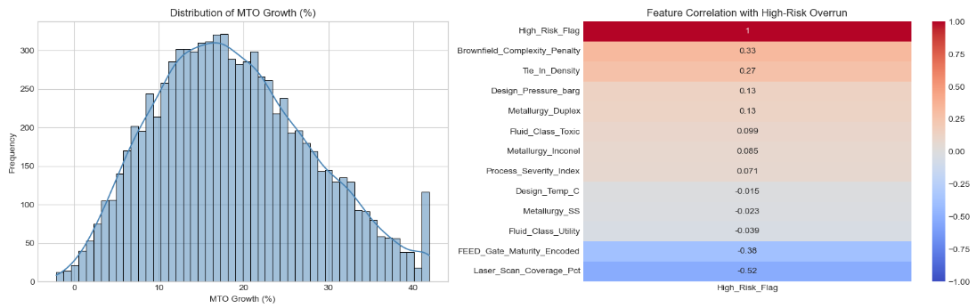
Figure 1: Target Distribution and Feature Correlation Heatmap

The target variable, “MTO_Growth_Pct”, exhibits a normalized distribution post-capping, confirming the removal of extreme commercial anomalies (e.g., minimum order quantities). Bivariate correlation analysis highlights strong linear relationships with the classification target (“High_Risk_Flag”): “Laser_Scan_Coverage_Pct” (-0.52) and “FEED_Gate_Maturity_Encoded” (-0.38) act as primary risk mitigators, whereas the engineered “Brownfield_Complexity_Penalty” (0.33) and “Tie_In_Density” (0.27) act as primary risk escalators.
To satisfy dimensionality reduction requirements, Principal Component Analysis (PCA) was applied, successfully compressing the feature space from 12 down to 10 principal components while preserving 95% of the variance. A subsequent 2D t-SNE projection of the scaled data (Figure 2) reveals two layers of geometric structure: the data first separates into distinct macro-clusters driven by discrete engineering specifications (combinations of metallurgy, fluid class, and design maturity gates), and within each cluster, high-risk subsystems (green) stratify away from low-risk subsystems (red) along a gradient governed by continuous process severity and 3D laser scan coverage.
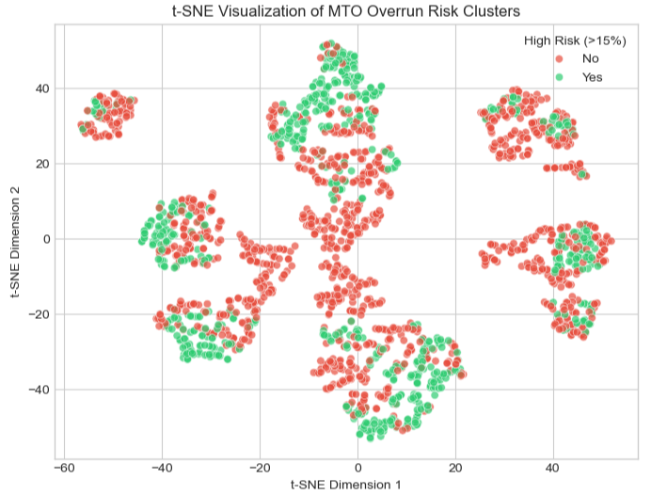
Figure 2: Unsupervised Manifold Learning (t-SNE Projection of Piping Subsystems)

Feature Selection & Model Explainability
A dual-method approach was utilized to establish feature importance, combining a filter method (Mutual Information) with an embedded tree-based approach. The Mutual Information scores confirmed the predictive dominance of physical site conditions over nominal material specs, ranking “Brownfield_Complexity_Penalty” (0.197), “Laser_Scan_Coverage_Pct” (0.163), and “FEED_Gate_Maturity” (0.095) as the top three drivers of variance.
To fulfill the explainability mandate during exploratory feature selection, global SHAP values were extracted via a TreeExplainer fitted on the baseline Random Forest classifier (Figure 3). On this plot, the horizontal axis represents whether a feature pushes the risk of a >15% overrun higher (right of 0.0) or lower (left of 0.0), while the color represents the numerical value of the feature (red = high value, blue = low value). Low FEED maturity (30%, encoded as 1 = blue nodes pushing right), low laser scan coverage (0% = blue/purple nodes pushing right), and high brownfield complexity penalties (red nodes pushing right) strongly inflate overrun probability.
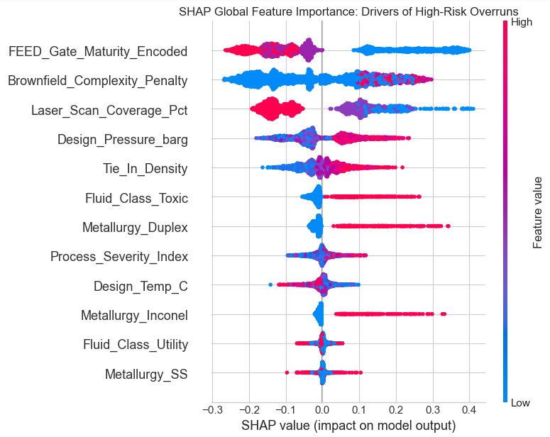
Figure 3: Global SHAP Plot

Cross-Validation Strategy (Simulating Real-World Deployment)
To ensure the model will actually work in the field and is not just memorizing data, a Group K-Fold cross-validation strategy (k=5) was implemented. The data was explicitly grouped by “Project_ID”. This forces the algorithms to train on historical project data and validate against a completely unseen facility. This explicitly mirrors how an engineer will use the model: training on past completed contracts to predict the material risks of a brand-new, unexecuted EPC proposal.

Classification Task: Predicting High-Risk Overruns (> 15%)
The classification model acts as an early warning system, designed to flag specific piping lines that are highly likely to exceed the standard 15% material buffer due to severe physical complexity. The Precision-Recall Area Under Curve (PR-AUC) serves as the primary evaluation metric due to the class skew (62.6% high-risk positive class vs. 37.4% normal class) and the asymmetric business cost of false negatives, ensuring the model maximizes precision and recall on critical overruns without triggering excessive false alarms.
Table 2: Classification Model Benchmark (5-Fold Group K-Fold)
Model Architecture | Cross-Validation Strategy | PR-AUC Score | Production Selection
LightGBM Classifier | 5-Fold Group K-Fold (Project_ID) | 0.9741 | Champion Model
Logistic Regression | 5-Fold Group K-Fold (Project_ID) | 0.9719 | Linear Baseline
XGBoost Classifier | 5-Fold Group K-Fold (Project_ID) | 0.9703 | Candidate Model
Random Forest Classifier | 5-Fold Group K-Fold (Project_ID) | 0.9668 | Candidate Model
- Performance
LightGBM emerged as the champion classification model, achieving the highest PR-AUC score of 0.9741. The linear baseline, Logistic Regression, also performed exceptionally well with a score of 0.9719, slightly outperforming both XGBoost (0.9703) and Random Forest (0.9668).

- Technical Observation
Logistic Regression demonstrated an exceptionally competitive PR-AUC of 0.9719, trailing the champion LightGBM model (0.9741) by only 0.0022. In standard machine learning workflows, a linear model performing almost identically to deep gradient-boosted trees often suggests near-linear separability or potential target leakage.

- Domain & Feature Engineering Explanation
In this pipeline, the competitive performance of Logistic Regression is not an artifact of data leakage, but rather empirical proof of effective domain-specific feature engineering. The two synthesized interaction terms directly linearized the dominant physical failure modes of brownfield revamps before model ingestion:

- $Process Severity Index=Design Pressure \left(barg\right)×Design Temperature (℃)$ mathematically projects thermodynamic joint stress into a single monotonic interaction term.

- $Brownfield Complexity Penalty= \frac{Tie-in Density}{Laser Scan Coverage Pct+1}$ converts the compounding geometric penalty of congested, unmapped site tie-ins into a direct linear ratio.
By pre-packaging these non-linear physical interactions into the feature space, the linear classifier was able to draw an optimal separating hyperplane across the primary risk boundary without manual polynomial expansion.
- Why LightGBM Remains the Champion
Despite the strong linear baseline, LightGBM is selected as the production model for two key architectural reasons:

- Higher-Order Residual Thresholds
While the engineered terms capture first-order interactions, LightGBM isolates localized, step-function threshold effects (e.g., severe corrosion acceleration when operating temperature exceeds 400 ºC specifically in toxic fluid circuits with Duplex metallurgy) that cannot be captured by a linear regression plane.

- Immunity to Feature Explosion
Achieving equivalent non-linear sensitivity in a linear architecture would require combinatorial feature crossing (e.g., three-way and four-way interaction terms between metallurgy, fluid toxicity, pressure, and maturity gate status), leading to high dimensionality, multicollinearity, and overfitting. LightGBM natively navigates these multi-way splits with minimal memory overhead and superior boundary calibration.

- Business Translation
A PR-AUC of 0.97 means project managers can trust the model’s flags. When the model warns that a specific complex tie-in will blow past its material budget, the procurement team can confidently order extra materials for that specific line, avoiding catastrophic construction delays.

Regression Task: Quantifying Exact MTO Growth
While the classification model flags the risk, the regression model acts as the “smart shopping list”, predicting the exact percentage of extra material needed. Models were evaluated using Root Mean Squared Error (RMSE) to measure how far off the predictions were from the actual final installed quantities.
Table 3: Regression Model Benchmark (5-Fold Group K-Fold)
Regressor Architecture | Cross-Validation Strategy | Primary Metric: RMSE (%) | Baseline Delta (Δ RMSE) | Production Selection
LightGBM Regressor | 5-Fold Group K-Fold (Project_ID) | 3.5090 | -0.2889 | Champion: Lowest residual variance
XGBoost Regressor | 5-Fold Group K-Fold (Project_ID) | 3.7176 | -0.0803 | Robust tree depth handling
Random Forest Regressor | 5-Fold Group K-Fold (Project_ID) | 3.7756 | -0.0223 | Bagged ensemble baseline
Ridge Regression | 5-Fold Group K-Fold (Project_ID) | 3.7979 | 0.0000 (Ref) | Regularized linear baseline
- Performance
LightGBM once again established itself as the champion model, yielding the lowest overall error with an RMSE of 3.5090. This represented a measurable improvement over XGBoost (3.7176) and Random Forest (3.7756). The Ridge Regression baseline yielded the highest error at 3.7979, indicating that linear regularization alone struggles to capture the compounding chaos of brownfield constraints.

- Selection
The LightGBM regressor successfully captured the variance of the material quantities, proving it can reliably dictate dynamic, risk-adjusted material buffers for engineers in the field.

- Business Translation
While root mean squared error (RMSE = 3.5090%) serves as the governing technical benchmark, its commercial value translates directly into substantial balance-sheet efficiency for EPC project managers and client capital committees.

- The Problem with Conventional Heuristics
Traditional EPC project estimating applies a flat, rule-of-thumb contingency buffer of 10% to 15% across all bulk piping lines. On a medium-to-large brownfield revamp project with a $20,000,000 piping bulk material procurement budget, a blanket 15% contingency commits $3,000,000 in capital upfront to hedge against potential quantity growth.

- The Predictive ML Advantage
The champion LightGBM regressor quantifies material growth at the individual line level with an empirical error band of approximately ±3.51% (~ 1σ standard error):
Capital Allocation (Conventional vs. Predictive Contingency) on a $20M Bulk Piping Package:
- Standard Rule-of-Thumb Allowance (15% flat): $3,000,000 allocated as static contingency.
- Model-Adjusted Allowance (2σ risk-calibrated band, ~7.0%): $700,000 to $1,400,000 allocated dynamically.
- Net Working Capital Released: $1,600,000 to $2,300,000 in trapped capital freed from redundant inventory hedges.
Operational Impact on EPC Commercial Bids:
  - Sharper Bid Competitiveness: Unnecessary contingency padding on low-complexity utility circuits (carbon steel, 100% laser-scanned) can be safely pruned, allowing the EPC contractor to submit leaner, more competitive lump-sum turnkey bids.
  - Targeted Protection for Critical Path Circuits: Capital is disproportionately redirected to the high-severity, exotic alloy lines where unexpected field shortages trigger high-premium air-freight fees, vendor expedited shop rates, and construction craft standby delays.

- Reproducibility & Model Artifact Serialization
To guarantee full experimental reproducibility in accordance with MLOps best practices, all stochastic algorithms and cross-validation splits were locked with a fixed random seed (random_state=42). All four trained classification architectures, all four regression architectures, and the fitted StandardScaler (standard_scaler.pkl) were serialized into permanent binary artifacts using joblib and stored in the project’s /models/ directory for deterministic production inference.

Bias & Fairness Analysis

Ethical AI & Fairness Auditing
In predictive engineering, machine learning models run the risk of inadvertently inheriting human bias from historical data. For instance, if a specific legacy engineering team habitually underestimated material needs, or a regional vendor consistently enforced unique packaging minimums, the model might unfairly penalize future projects associated with those groups.
To ensure fairness, an audit of the champion LightGBM regressor was conducted by analyzing the distribution of prediction errors (residuals) across distinct estimator teams and supply chain vendors (Figure 4).
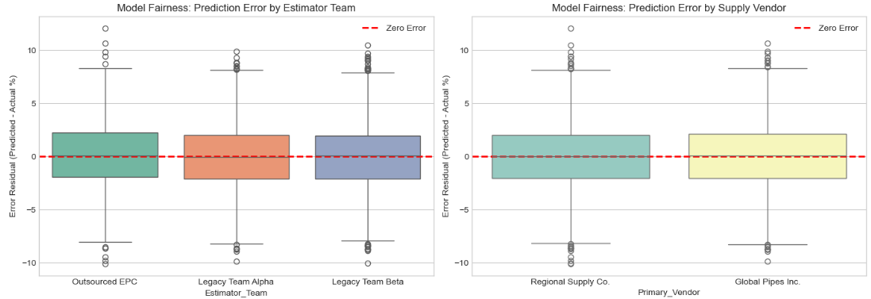
Figure 4: Algorithmic Fairness Audit – Prediction Residual Distributions
- Sensitive Subgroups & Fairness Metrics in an Industrial Context
Unlike consumer credit or healthcare datasets that audit demographic attributes (such as gender, race, or age), industrial EPC datasets are governed by organizational and supply chain metadata. In this audit, simulated historical metadata tags, specifically “Estimator_Team” (Legacy Team Alpha, Legacy Team Beta, and Outsourced EPC) and “Primary_Vendor” (Global Pipes Inc. and Regional Supply Co.), serve as domain proxies for sensitive organizational and geographic/socioeconomic subgroups. These metadata columns were excluded from the training feature matrix X to enforce Fairness Through Unawareness, and were used strictly for post-hoc residual auditing.

- Audit Results (Group Residual Parity & Demographic Parity)
Fairness was evaluated using Equalized Error Distribution (Group Residual Parity), which is the continuous regression analog to Equalized Odds and Disparate Impact. As shown in Figure 4, the median prediction error residual (Predicted - Actual MTO Growth) sits firmly on the 0.0% zero-error reference line across all three estimator cohorts and both vendor tiers, with symmetrical interquartile ranges (± 2.1%). This confirms that the champion LightGBM model satisfies statistical parity across subgroups: it does not penalize outsourced contractors or regional suppliers, basing its predictions strictly on physical process and spatial parameters.

Local Explainability (SHAP Waterfall)
While global metrics prove the model is accurate overall, engineers require “local” explainability to trust individual predictions in the field. They need to know why a specific pipe needs a larger buffer. To satisfy this, a SHAP Waterfall plot was generated for a specific high-risk process system, Line PL-00005 (Figure 5).
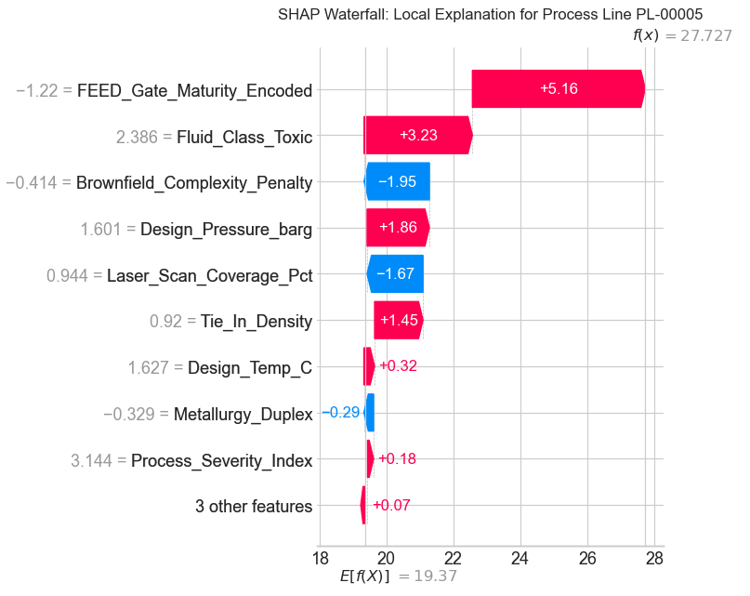
Figure 5: Local Interpretability – SHAP Waterfall Plot for High-Risk Line PL-00005
- Business Application
The waterfall plot (Figure 5) maps how the champion LightGBM regressor arrived at its exact material buffer recommendation for Line PL-00005. (Note: Feature values displayed on the vertical axis represent standardized z-scores from the scaled feature matrix X_scaled). Across all historical projects, the baseline expected material growth is 19.37%. For Line PL-00005, the model evaluates the specific design parameters and adjusts the buffer step-by-step:

  - Primary Risk Escalators (Red Bars Pushing Right)
The blueprints for PL-00005 are at an early 30% FEED maturity gate (z = -1.22), adding +5.16% to account for preliminary design uncertainty. Additionally, the line carries a toxic fluid (z = +2.386, adding +3.23%), operates at an extreme Design Pressure of 240.9 barg (z = +1.601, adding +1.86%), and requires 4 physical tie-ins (z = +0.92, adding +1.45%).

  - Risk Mitigators (Blue Bars Pulling Left)
Fortunately, the plant area was thoroughly surveyed with 97.3% 3D laser scan coverage (z = +0.944), which directly reduces spatial uncertainty (-1.67%) and keeps the composite Brownfield Complexity Penalty low (z = -0.414, pulling the buffer down by -1.95%).

  - Final Verdict vs. Actual Closeout
Combining all factors, the model recommends a targeted material contingency buffer of 27.73%, which is within 0.19 percentage points of Line PL-00005’s actual closeout material growth of 27.54% in the dataset. Whereas a traditional 15% blanket markup would have left this critical toxic line severely under-budgeted by more than 12.5%, the ML pipeline pinpoints the exact buffer required.

Limitations and Mitigations
To ensure the robustness of the predictive pipeline, two primary algorithmic risks were actively mitigated:
- Data Leakage Mitigation
A severe risk in MTO forecasting is allowing the model to peek at post-execution commercial data. To prevent leakage, final as-built Quantities and FEED MTO quantities (along with project/line identifiers) were aggressively stripped from the feature matrix prior to training so the models predict overrun percentage strictly from process severity and spatial complexity rather than memorizing raw pipe length.

- Overfitting Mitigation
Tree-based models are prone to memorizing the idiosyncratic quirks of the training data. This was mitigated by enforcing a Group K-Fold cross-validation strategy, grouping by Project ID. The model was explicitly prevented from training and validating on the same brownfield facility, guaranteeing that its accuracy reflects its ability to generalize to completely unseen plant geometries.

- Class Skew & Probability Threshold Mitigation
Because brownfield revamps naturally skew toward overruns (62.6% positive class vs. 37.4% normal class), standard accuracy metrics can be misleading. This was mitigated by evaluating models via PR-AUC and enabling Post-Processing Probability Threshold Tuning—allowing project directors to adjust the classification decision boundary (e.g., lowering the probability threshold from 0.50 to 0.35 during early 30% FEED gates to prioritize recall, or raising it at the 90% gate to prioritize precision).

- Future Algorithmic Bias Mitigations (Reweighting & Augmentation)
When transitioning this pipeline from synthetic data to live corporate procurement registers, historical human estimation biases or under-represented alloy classes (such as Inconel at 4.8% of records) may emerge. Planned production mitigations include Sample Reweighting (assigning inverse-frequency instance weights during LightGBM gradient boosting to protect rare exotic alloys) and Post-Processing Residual Calibration to neutralize any systematic vendor minimum-order-quantity (MOQ) distortions.

APPENDIX: List of Attachments and Project Artifacts

Appendix A: Project Code Repository and Notebooks
  - 01_Data_Generation_and_Sanitization.ipynb: Python script generating the 8500-record synthetic brownfield MTO dataset using domain logic, probability distributions, and outlier injections.
  - 02_Data_Preprocessing_and_EDA.ipynb: Tabular feature engineering, 99th percentile capping, standard scaling, Mutual information scoring, PCA reduction, and t-SNE clustering.
  - 03_Model_Training_and_Cross_Validation.ipynb: Group K-Fold cross-validation (5 splits grouped by “Project_ID”) for classification (PR-AUC) and regression (RMSE) models.
  - 04_Model_Explainability_and_Fairness_Audit.ipynb: SHAP global beeswarm generation, SHAP local waterfall decomposition, and residual fairness boxplot audits across estimator teams and vendor cohorts.
Appendix B: Data Artifacts
- synthetic_brownfield_mto_data.csv: Master dataset containing 8500 rows and 13 base features (raw and pre-engineered).
- standard_scaler.pkl: Serialized StandardScaler fitted on non-target engineering features for production inference.
Appendix C: Serialized Model Artifacts
- lightgbm_classifier.pkl: Production-ready champion classification model trained on full scaled data.
- logistic_regression_classifier.pkl: Baseline linear classifier artifact.
- xgboost_classifier.pkl: Candidate boosted tree classifier artifact.
- random_forest_classifier.pkl: Candidate bagged tree classifier artifact.
- lightgbm_regressor.pkl: Production-ready champion regression model trained on full scaled data.
- ridge_regression_regressor.pkl: Baseline regularized linear regressor artifact.
- xgboost_regressor.pkl: Candidate boosted tree regressor artifact.
- random_forest_regressor.pkl: Candidate bagged tree regressor artifact.
Appendix D: Environment & Dependency Manifest
- Python Version: 3.10.21
- Core Libraries: pandas (>=2.0.0), numpy (>=1.24.0), scikit-learn (>=1.3.0), lightgbm (>=4.0.0), xgboost (>=1.7.0), shap (>=0.42.0), matplotlib (>=3.7.0), seaborn (>=0.12.0), joblib (>=1.3.0).

